# Lab: Introduction to Bootstrap

Problems for exercises and homework for the ["JavaScript For Front-End Course @ SoftUni"](https://softuni.bg/trainings/2699/javascript-for-front-end-december-2019).

Do not use any custom **CSS**, only **Bootstrap** is **required**.

## Grid System

Look at [Bootstrap Grid System documentation](https://getbootstrap.com/docs/4.1/layout/grid/) and create a web page like the following:

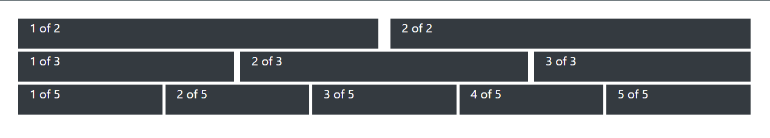

### Hints

* Use class **row** for each line
* Define containers with class **col** inside every row
* Use margin (**m-3**) class for the main container
* Use **bg-dark** background color for every column

## Navigation Bar

Create a web page like the following:

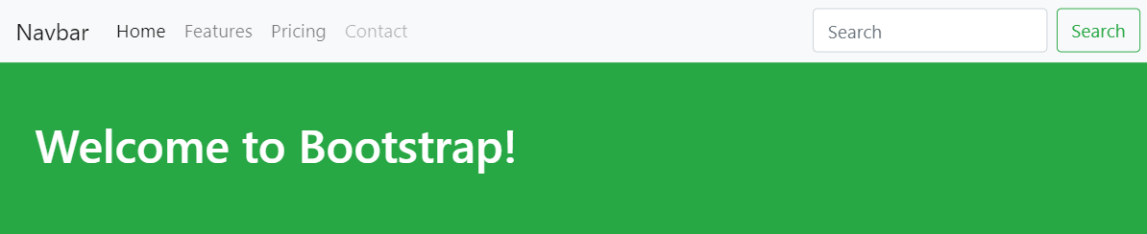

### Constraints

* Read about **navigation** **bars** at <https://getbootstrap.com/docs/4.1/components/navbar/>

## Table

Create a web page like the following:

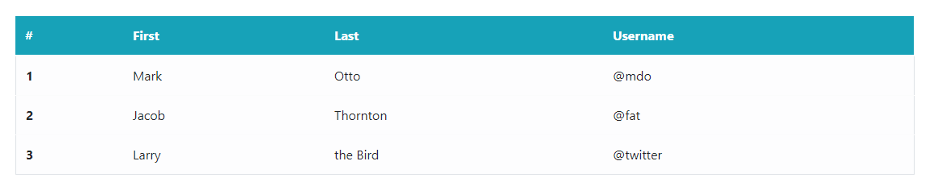

### Constraints

* Read about **tables** in **Bootstrap** at <https://getbootstrap.com/docs/4.4/content/tables/>

## Form

Create a web page like the following:

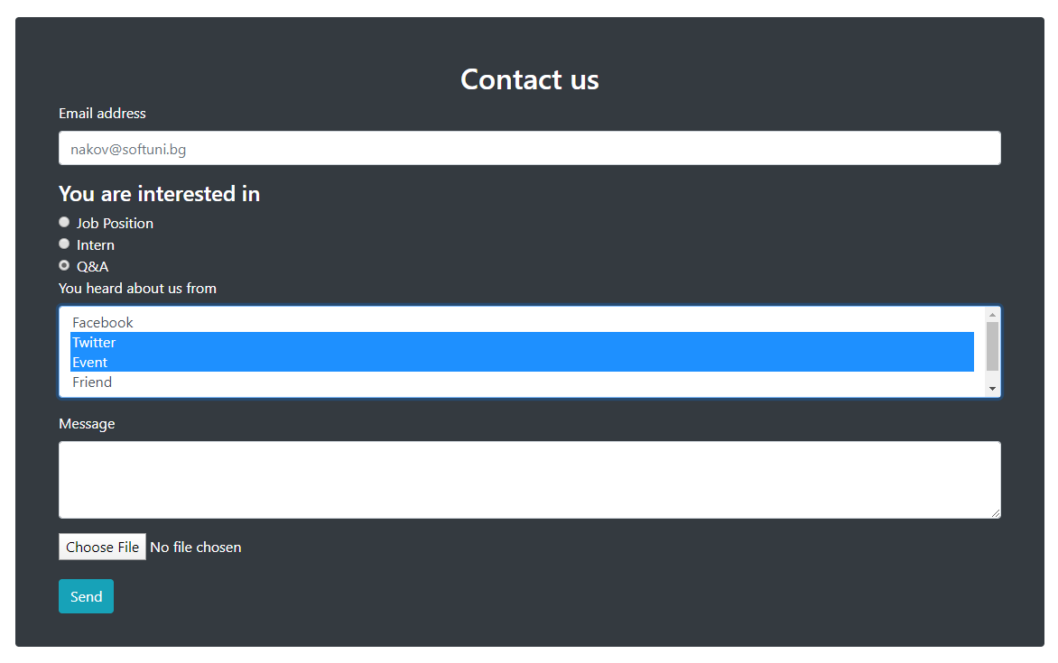

### Constraints

* Read about **forms** in **Bootstrap** at <https://getbootstrap.com/docs/4.1/components/forms/>